**Understanding two information carrying words**

For more information about what information carrying words are, please see the handout ‘Introduction to information carrying words’ on our website.

Before a child can understand long sentences, they need to be able to follow short phrases. These ideas will help develop this skill.

1. Collect a range of objects or pictures of objects (e.g., car, keys, banana, brick). Ask the child to find 2 out of 4 at a time (e.g., "Find the car and the keys").

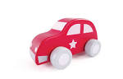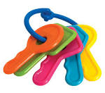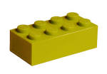   
  
  
  
  
  
  
  
  
  
The child can put them in a bag or give them to you. Continue, always choosing from 4 objects and say 2 of them at a time. If he gets just one, repeat both items again.

1. 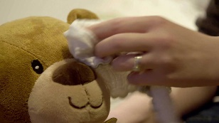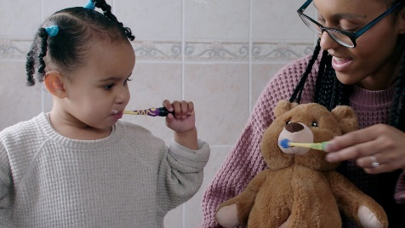Collect a teddy, brush, toothbrush, flannel. Ask the child to:  
     
   brush teddy’s hair  
   brush teddy’s teeth  
   wash teddy’s face  
   wash teddy’s tummy  
   etc.
2. 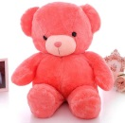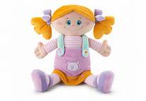Collect teddy and dolly plus other objects. Ask the child to  
     
   give teddy a plate  
   give dolly a cup   
   etc.  
     
   You could make this into a tea party game.
3. 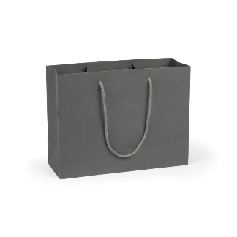Collect a bag, a box, and other objects. Ask the child to:  
   put a sock in the bag  
   put the cup in the box  
   etc.
4. 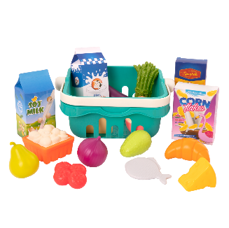Play a shopping game with toys or food items. Ask the child to buy two items at a time, e.g., “I’d like some milk and cheese” etc.