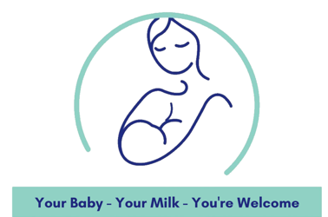

Breastfeeding Support & Social Groups are social support groups for all families feeding their babies breastmilk either directly from the breast, or via a bottle, exclusively or in combination with formula.

They can be found in the following places:

Bedford Borough | Day | Time
Daisy Hill Children’s Centre, Kempston, MK42 8QH | Monday | 09.30 – 11.30
Queens Park Neighbourhood Centre MK40 4LE | Tuesday | 09.30 - 11:30
Cherry Trees Children’s Centre, Bedford, MK42 9LS | Wednesday | 13.30 - 15.00
Goldington Family Centre, Bedford, MK41 9HU | Thursday | 09.30 - 11.30
Pine Cones Children’s Centre, Bedford, MK41 7SA | Friday | 09.30 - 11.30

Central Bedfordshire | Day | Time
Flitwick Children’s Centre, Flitwick, MK45 1PU | Monday | 13.30 - 15.00
Sandy Children’s Centre, Sandy, SG19 1HQ | Tuesday | 11.00 - 12.30
Dunstable Children’s Centre, South Site  Downside, LU5 4AS | Thursday | 13.00 - 14.30
Biggleswade Library, Biggleswade, SG18 0LL | Thursday | 13.30 – 15.00
Shefford Children’s Centre, Shefford SG17 5XA | Friday | 11.00 - 12.30
Leighton Buzzard CC, Leighton Buzzard, LU7 1EW | Friday | 10.00 - 11.30
Houghton Regis CC, Parkside Site, LU5 5QN | Friday | 10.30 - 12.00

Luton | Day | Time
Farley Community Centre  Delphine Close, Luton LU1 5RE | Tuesday | 09:30 – 11:30
Hockwell Ring Community Centre and Family Hub  Mayne Avenue, Leagrave, Luton LU4 9LB | Tuesday | 13:00 – 15:00
St Francis Church  Carteret Road, LU2 9JZ | Thursday | 09:30 – 11:30
Pastures Way Nursery  Pastures Way, Luton LU4 0PE | Friday | 09.30 – 11:30

For further information speak to your health visitor (0300 555 0606) or visit:
NHS Bedfordshire Children & Young People’s Services Facebook Page (@BedsCYP) or www.bedslutonchildrenshealth.nhs.uk/baby-friendly

