Zones of Regulation

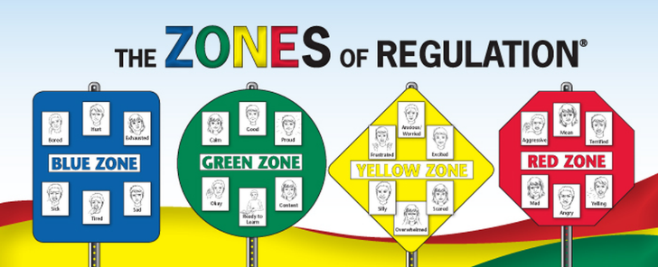
What is it? A visual method of representing emotions and how you can use strategies to regulate them.

Steps
- Decide on the visuals: chart (e.g., favourite film characters), reminders (e.g., on desks, around school, as a bag tag), moveable identifier (e.g., photo of child)
- Use a range of photos to help the child identify emotions in others
- Start modelling the zones and do so consistently. The starting point is to have check-ins at certain times of the day or in response to significant changes in behaviour. To do this, label what you see the child doing, and the emotion that these non-verbal signs usually link to, then place the child’s photo in the zone the emotion is in; remember to model this with others who are present too. As the child’s knowledge grows, they can begin to move their photo between zones.
- Once the child can label the zone they are in, talk about what works for you when trying to regulate your emotions (e.g., how you return to your green zone). Make a record of anything the child identifies for themselves.
- Continue to develop a personal profile of strategies and include these on the chart. Over time, once the child places themselves into a blue or yellow zone, they should be able to choose something to get them back to their green zone if this is needed. Remember that if they are in the red zone, they will simply need to be told what to do to calm down if they need to (i.e., do not give choices in this situation).

Top tips
- Make it personal: What works for one child may not work for the next. The shapes for the zones in the poster relate to road signs for ‘rest area’, ‘go’, ‘slow’ and ‘stop’ for those children who have an interest in transport. There are resources on the internet related to the ‘Inside Out’ film, Emojis and Widgit symbols. Personalise the visual way the Zones are represented, the way the emotions are represented, and the regulating activities. Some people prefer a vertical format rather than horizontal format for the chart itself.
- Model, Model, Model: Check-ins, when built into the routines, can change habits. Be aware of cognitive skills, and which emotions are likely to be recognised first. Talk about what you see when people experience an emotion (e.g., eyes, eyebrows, mouth, body language). Explain idioms that are associated with different zones or feelings. Being in zones other than green can be useful (e.g., in blue before bedtime, excited before a birthday).
- It’s ok to not be ok: Even if an emotion cannot be ‘fixed’, it is still experienced and should be acknowledged. Everyone experiences things differently, so do not assume you know what someone else is feeling. Feelings influence thoughts and actions, then link these to how others respond. Remember, some children rarely experience the green zone.

