What I need to do
1

Task Plan
2
3
Task:
What is the activity?
What do I need?
What equipment do they need to complete the task.
This is an example of a task plan. You may want to add in:
What do I need to do?
Write the small steps they need to do to complete the activity.
What to when I have finished?
How long should this take?
Reward activity

Task Plan

What do I need? | 1 …………………………… | 4 ……………………………
 | 2 …………………………… | 5 ……………………………
 | 3 …………………………… | 6 ……………………………

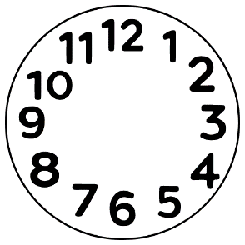
What do I need to do?
1 ………………………………………………………………………
2 ………………………………………………………………………
3 ………………………………………………………………………
4 ………………………………………………………………………
5 ………………………………………………………………………
6 ………………………………………………………………………
7 ………………………………………………………………………

Anything else?
1 ………………………………………………………………………
2 ………………………………………………………………………
3 ………………………………………………………………………
How long?
Reward

