Comic Strip Conversations

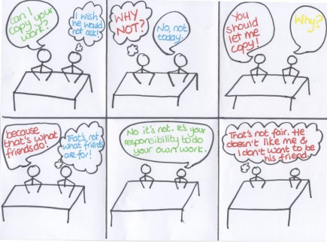
What is it? A visual representation of a conversation that shows what people are thinking and feeling, as well as saying. They make the abstract more concrete when thinking about how thoughts relate to what we say.

Why? To problem-solve social scenarios, after it has occurred, and to encourage the young person to make a ‘sensible guess’ about other people’s thoughts.

Steps
- Divide the whiteboard into 6 equal boxes.
- Use your own situation the first time you are trialling this.
- Draw stick people, a little background and what they said in speech bubbles.
- Revisit each box and fill in your own thoughts. Then encourage the child to think about what the other person in the scenario may have been thinking. Reassure them about ‘sensible guesses’.
- Move on to draw the situation involving the child and model ‘sensible guesses’ yourself.
- Let the child correct your guesses.
- Use spare boxes or another sheet to model how changing thoughts, speech or actions can have an impact on the outcome of a situation.

Top tips
- Introduce thoughts and speech to begin with, then move onto something the child needs to increase their awareness of (e.g., interrupting, speaking too loudly).
- Reduce the completeness of your Comic Strip Conversation over time, allowing for corrections and extensions by the child.
- Only use one pen between you and the child to pace the conversation.
- Begin your drawings in the second box, as something has always happened before the situation. Equally, having a few boxes for alternative endings can be helpful too.
- Keep a record of progress by underlining the child’s contributions and photocopying the whiteboard.

