**Developing vocabulary skills**

All curriculum areas have key words and concepts that children need to understand and use in their spoken language if they are to talk about what they have done and what they are going to do. It is important that you identify such words and develop strategies to ensure that opportunities are given for learning and using them confidently.

**Key words and concepts**

Often classroom staff will quite explicitly set out to teach colour and shape concepts in mathematics, while in science, parts of the body or plants may be considered important words for children to learn to use if they are to talk about their observations. In English, children learn what ‘author’ and ‘illustrator’ mean and, with experience, will use these words in their discussions about books. Therefore, at the planning stage, key words and concepts can be written down and teaching strategies developed to ensure children learn them.

Difficulties in selecting key vocabulary can arise for two main reasons. Firstly, a topic may involve a considerable amount of vocabulary – which are the **key** words and ideas to target? Secondly, in a large class, with a wide range of ability, knowledge, and experience, which vocabulary should be taught to which children?

1. **Identify the key vocabulary**

During research and planning for a topic, you need to identify vocabulary, particularly specialist vocabulary, that children might be expected to learn. It is useful to select a small number of words or concepts (6-12) that are essential to children’s understanding and a more advanced bank of core words that would be helpful.

**2. Find out what pupils already know about the topic**

With a reasonable idea of the range of vocabulary that is involved in the topic, you then need to address the children’s current understanding and confidence to such words. Assume that all new topics contain new vocabulary for most children. If most of the vocabulary is new to a child, they will likely have difficulty keeping up with class instructions, activities, and discussions.

**Whole class discussion**

**Ask** children what they know already. This needs to take place before the topic begins, so that there is time for planning based on the information gained. Using an activity, a story, or some pictures related to the topic, you can set the scene and encourage the class to talk about their current knowledge. While this can be done at whole class level, there is a danger that the most verbal children will contribute more and it will be unclear if the less confident children or children with Speech, Language, and Communication Needs (SLCN) have the same understanding and knowledge.

**Groups**

In small groups, ask the children what they know about a topic. As they talk about the topic, you can make a note of key words and phrases used by them. It may also be useful to ask the groups what they would like to know about the topic and to incorporate this into the planning process.

**Strategies to develop vocabulary**

**Use visuals:** Where possible, always introduce a new word, idea, or concept using visuals to make it meaningful for the child. Plan how this can be achieved. For example, when discussing the desert, use pictures, small world objects, e.g., camels, lizards etc., real world objects, e.g., a cactus, sand etc.

**Think about word storage:** Support pupils to lean new word and store them in an organised way. To do this, children need to develop their understanding of the meaning of the word and how it relates to others (category knowledge), as well as how the word sounds, what it looks like etc. Introduce new words or ideas using a plan:

* What it is: “This is a desert” (showing a picture)
* Describe it: “Deserts are places that do not get much rain, so it is very dry. They are usually covered in sand, rocks and sometimes plants. It is usually very hot.”
* Location: “There are deserts in many continents of the world, like the Sahara Desert in Africa”
* Initial sound: “Desert starts with ‘d’”
* Length of word: “it is a longer word”
* Syllables: “It has 2 syllables: des-ert”

Use word maps to support this.

For information about word maps, please see the handout about this on our website.

**Context:** Children need to hear new words used in contexts that are meaningful if they are to understand them and appreciate how they are used. For young children and children with SLCN this is likely to mean that learning will happen most effectively when opportunities are given for **listening and talking** around a variety or practical activities, as well as about stories, poems, and information books. For example, many ideas in science are complex and while a demonstration of some aspect is useful, it is usually the opportunity to ‘have a go’ that sparks discussion and thought. Making a circuit, for example, is much more likely to encourage children to learn the specialist vocabulary involved and to explore complicated ideas.

**At the start of each lesson:** Revisit key words introduced at the last lesson. Write key words on a board and talk about them. This helps children gain a better understanding of the talk that begins the lesson and of the following activities. It also helps children see the connection between spoken and written language in a highly relevant situation.



**Pre-teaching:** Give children the opportunity to talk about key words and concepts with an adult so that, when they are involved in a whole class lesson, they have had some preparation for the questions, explanations, and discussions. Perhaps create a scrapbook or category book of key words together (see below).

**Use a category book:** Make up a word book with the child (a book with one page for each category). The categories should be selected by the child, e.g., science, countries, animals etc. Encourage the child to write any new words that they learn about in this book. The category could be divided into smaller categories, e.g.,

Animals Zoo : elephant

giraffe, etc.

Farm : cow

pig, etc.

Pets : dog

cat, etc.

It may help to underline or colour the first sound of the word.

At the end of each week, revise words in the book by having a ‘quiz’, i.e., you say the word and the child gives a definition or you give the definition, and they have to find the target word.

**Classroom layout:** Areas of the classroom are sometimes designated for particular aspects of the curriculum. For example, there may be listening or writing areas, book corners, sand and wet play, or craft areas etc. All such areas of the classroom invite talk and it is helpful to think through some of the key words or concepts that might be developed as children play and work in these areas and to put these up on the walls. This is valuable to remind adults to check understanding and encourage use as well as developing children’s ability to read and write the words.

For example, charts and labelled pictures of key words near the water play area could include:

* the names of equipment used (e.g., water wheel, funnel, tube)
* verbs (e.g., pour, float, sink)
* 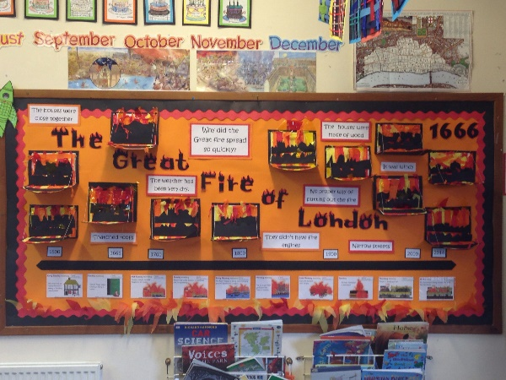adjectives (e.g., full, empty, half full, big, heavy, plastic)

Consider a display board for the topic you are working on and include key words within the display.

**Definitions:** Look up key words together online. Encourage older children to use dictionaries to find out the meanings of new curriculum words and ‘quiz’ each other on word definitions. Games and activities such as ‘Hangman’, crosswords, word bluff etc. encourage talk about words and their meanings as well as being fun.

**Use spider diagrams:** Provide the key word, at the centre and then ask the child to think of associated words. Ask the child to say why they go with the key word, e.g.

hive insect

honey

stings flowers

Revise the words at the end of the week either by telling the child the associated words and see if they can name the central word or by telling the child the central word and asking them to remember as many of the associated words as they can.

**Use word trees**

Use a ‘word tree’ to show how words are related, e.g., using the topic of plants:

**Fridge words:** Share topics and key word lists with parents/carers so they can support the child’s knowledge and understanding at home.

**Consolidation:** Revisit key words and concepts in as many different ways as possible across the curriculum to give the opportunities for consolidation. This enables children to hear the vocabulary numerous times, learn it, store it accurately, and demonstrate their learning through relevant activities.

**Assessing vocabulary:** The best way to assess children’s acquisition of items of vocabulary is to have them respond to the use of a word by others and hear them use words spontaneously. The amount of time this takes for every single key word or concept makes it virtually impossible in classroom contexts. A further difficulty is that while all children need repetition of words in varying contexts to help them consolidate understanding and expression, they will vary in the amount of repetition they need to establish learning. Try to provide plenty of opportunities to practise hearing and using new words. Ideas for assessing include:

1. Ask the child to use the key word in a sentence.
2. Give clues for the key words and ask the child what word you are referring to, e.g., I am in the sky, I am round, I shine at night = (moon). This could also be made into a reading comprehension exercise or done in pairs / small groups. Reverse roles: ask the child to give clues for key words and you / other children guess what word they are referring to.
3. Check the breadth of the child’s understands by asking them to give:
   * another word that means the same
   * words that are opposite
   * words in the same category (e.g., colours, fruit, furniture, etc.)
   * play word association games
   * words beginning with the same sound
4. Encourage the child to learn their own new words around a topic, writing them on a class topic board, or in individual topic books.

**Some ideas have been taken with permission from handouts by Anne Locke, Department of Human Communication Sciences, University of Sheffield**