Storytelling and Narrative Skills

Narrative is the ability to tell a story or series of events with precision and clarity. Narratives can be in either spoken or written form. We use narrative skills every day in order to socialise, describe and explain, e.g.
- Talking about what happened at the weekend
- Telling a teacher about an incident in the playground
- Retelling a story, e.g., the plot from a book, film or TV programme
- Having a conversation in the playground with friends
- Making plans or predictions about future events

Narratives follow a structure and are organised into a sequence, usually a beginning, middle and end. Narratives centre around a plot which usually includes a location, characters, a time, and a main event.

To be a successful communicator of narratives, you need to be able to attend and listen, retain and recall information, understand the language used, formulate language using the correct words and grammar, all in an organised order, known as a sequence. Therefore, producing narratives, i.e., telling a story / sharing news / reporting an incident, can be difficult for children and young people with Speech, Language and Communication Needs.

Narrative development
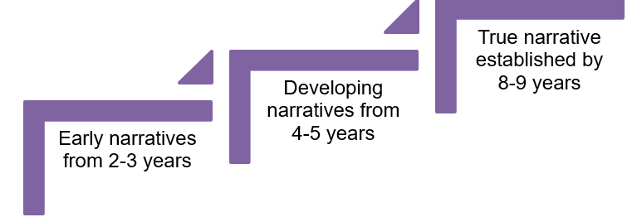

Indicators of difficulties with narrative

- Use of shorter narratives containing less detail
- Difficulties setting the scene (i.e., ‘launching’ into details without giving background information)
- Difficulties linking events together (causal relationships)
- Disorganised story which is not coherent
- Include irrelevant details that disrupt the story
- Reduced vocabulary and use general words such as “things,” “this,” “that.”
- Less grammatical complexity, e.g., tense marking
- May find common sequences hard to remember, e.g., days of the week.

Impact of difficulties with narrative

- Difficulties accessing the curriculum at an age-appropriate level
- Unable to talk about things that have happened or explain things clearly
- Difficulties reading for meaning; making inferences, getting the main idea
- Tricky for someone to understand and follow what they are saying.
- Peer relationships can be affected (e.g., not being able to talk about things that have happened or explain things clearly).

Strategies to support narrative skills

- Model appropriate sentences and stories, and include sequencing terms like ‘first’, ‘next’, ‘then’, ‘finally’ etc.
- Support sentence repair by modelling their sentence back to them.
- Use visuals like objects, pictures, gestures, actions, signs and drawing to bring stories to life.
- Use everyday activities to model narrative and sequence, e.g., when getting dressed, completing a task in a lesson, having a snack etc.
- Share books including wordless books. Books with repetitive phrases / scripts can support memory of the story and encourage organising, e.g., “Once Upon a Time”
- Amend familiar stories to encourage active listening, e.g., change the characters, the location, the ending etc., and encourage the children to listen out for the differences. Then, encourage the children to amend parts of familiar stories themselves.
- Play games; model the narrative of the game using appropriate language, e.g., “We each have a counter, then we roll the dice and take turns to move our counter the correct number of spaces. If we land on a ladder, we can climb up the ladder to the upper space. If we land on a snake, we slide down the snake to the lower space. The first person to reach the end is the winner.”
- Take time to share news, e.g., from the weekend / last holiday / playground etc.
- Offer role play opportunities.
- Use first, next and last templates to help structure events.
- Use story planners/narrative frameworks to help structure stories, e.g., ‘beginning’, ‘middle’ and ‘end’. Examples of these are available on our website.
- Highlight key vocabulary in lessons and reinforce this whenever possible
- Use visual timetables and reference explicitly to events e.g. “First it’s maths, next it’s lunch”.
- Use colour coding approaches to show that question words relate to story components, e.g., who = characters, what doing = what happened (events), where= location (places), when = time, what like = description of characters/ settings.
- Use timelines to make concepts of past events explicit.

