Childrens Continence Referral Pack

It is an expectation that all children and young people should have received at least 6months of support with their continence prior to a referral being completed

If all information is not provided, referrals will not be accepted and they will be returned

Referral Criteria;

Bedford
- CYP referred with constipation aged 0years to 16years
- CYP referred for daytime wetting aged 5years to 16years
- CYP referred for night time wetting aged 5years to 16years where a trial of Desmopressin has been unsuccessful
- CYP that are living within the commissioned geographical boundaries (Bedford) and are registered with a GP within the commissioned area.

Luton, Dunstable & Leighton Buzzard
- CYP referred with encopresis (Pooing inappropriately without signs of constipation) aged 5years to 16years
- CYP referred for night time wetting aged 5years to 16years where a trial of Desmopressin has been unsuccessful
- CYP that are living within the commissioned geographical boundaries (Bedford) and are registered with a GP within the commissioned area.
- Currently daytime wetting and constipation are managed within primary care and Luton & Dunstable Hospital as appropriate

Bedfordshire SEND Toileting Support
- CYP aged 4years to 18years
- CYP that have a diagnosed / identified complex physical condition or learning difficulty diagnosis that contributes to a bladder or bowel dysfunction or difficulty with toileting.
- CYP that are living within the commissioned geographical boundaries (Bedfordshire and Luton) and are registered with a GP within the commissioned area.
- Provision of containment products will not be considered until 5years of age, and then only after the child or young person has undergone a comprehensive bladder and bowel assessment and engagement with a targeted individualised toilet skill development programme for at least 6months in all settings where the child spends their time.
- Children in Residential Schools (out of area) that are requiring containment products. Products are supplied by The Trust according to the child’s home address and are delivered to the CYPs home address, it is the parent’s or guardian’s responsibility to send / ensure appropriate amounts of containment products are available at the school.
CYP identified on an end-of-life pathway will be considered on individual assessment of need for containment products
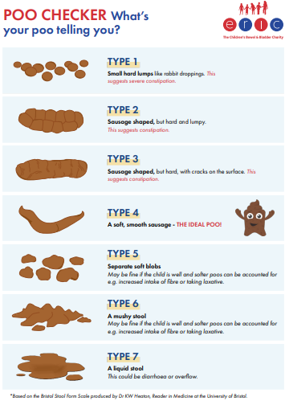
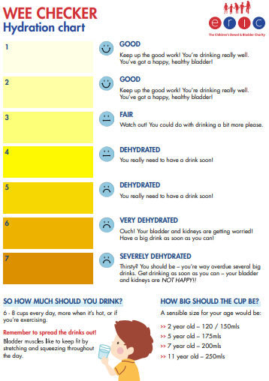

Simple Measure Advice

Ensure adequate fluid intake for all
6 months: 1 year 500-600ml
1-3 years: 900ml-1 litre
4-6 years: 1 litre
7-9 years: 1.5 litres
10-12 years: 1.5-2 litres
12+ years: 2-3 litres

Bowel problems
• Ensure adequate fluid intake throughout the day along with access to the toilet
• High fibre diet where possible
• Good toilet positioning with step/stool
• Consider toilet routines after meals, sitting for up to 10 minutes, actively trying to poo
• ** MACROGOLS should be the first line management for all constipation **

Simple measures for wetting
• Check for constipation and treat if needed
• Ensure access to water based drink throughout the day along with access to the toilet (consider asking for a school toilet pass if appropriate)
• Avoid fizzy drinks, caffeine/decaffeinated drinks (inc. hot chocolate), fresh orange juice
• Boys sitting to pass urine
• Double void before bedtime
• Attempting to stop drinks 2 hours before bed

SEND Toileting
See https://eric.org.uk/potty-training/children-additional-needs/ and https://www.bbuk.org.uk/children-young-people/resources-for-children/

N.B. Incomplete Forms will be returned to the referrer

Please complete all boxes
NHS Number |  |  |  |  |  |  | Date of birth
Name |  |  |  |  |  |  | Gender
Address: |  |  |  |  |  |  | Spoken Language
 |  |  |  |  |  |  | Interpreter Needed? |  | Yes No
Parent/Carer
Name/s
Contact Number

Bedford GPs only  (Select as appropriate) |  |  |  | Constipation | Daytime Wetting |  |  | Night Time Wetting
Luton, Dunstable, Leighton Buzzard only (Select as appropriate) |  |  |  | Encopresis |  |  | Night Time Wetting
Bedfordshire SEND only (Select as appropriate) |  |  |  | SEND Toileting |  |  | SEND Products
Give Details of Support Given to child/parent/carers:
Toilet training,
Reward Charts, toilet routines, fluid input advice, medication, simple measures, etc.
Any significant life events?
Bristol Stool  Type/s |  |  |  | Soiling Yes  No |  | Continence Medication
Medical History
(Include diagnosis known or suspected)

Any learning difficulties for child / parent
School/Nursery |  |  |  |  |  |  | Current Safeguarding? Yes No  Details:
Social Worker Details
Referrer |  | Referrals will only be accepted when completed by a health professional
Name/Job title
Contact number
Date

