**Understanding three information carrying words**

These are ideas to develop understanding of three information carrying words in a sentence. For example, “Tom's coat is over there on the peg”.

For more information about what information carrying words are, please see the handout ‘Introduction to information carrying words’ on our website.

1. 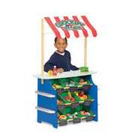**Giving three items on request**

Say three things for the child to give you, from a small selection. You could try this in the following games or activities:

* [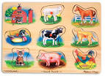](http://www.google.co.uk/url?q=http://adam-and-friends.blogspot.com/&sa=U&ei=_Zz9U7PWH8nb7AbImICoCA&ved=0CC4Q9QEwDA&usg=AFQjCNETYKUs-VdVQwQX18XMDlTa0O6_cA)Shopping game: Collect objects/food for a pretend shop. Ask the child to go and 'buy' three things. Take it in turns. For example, “Give me an apple, a banana and a biscuit”.
* Puzzles: Tell the child which three pieces to take out or put back.
* [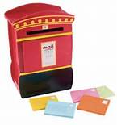](http://www.bing.com/images/search?q=toy+post+box&qs=n&form=QBIR&pq=toy+post+box&sc=1-11&sp=-1&sk=#view=detail&id=F86806C2EBDDB8290E01EFBB59D522C0FF1A40DC&selectedIndex=11#view=detail&id=F86806C2EBDDB8290E01EFBB59D522C0FF1A40DC&selectedIndex=11)Posting: Cut a hole in a cardboard box to make a post box. Take it in turns to tell each other to post three pictures or objects.
* Everyday activities: when putting the washing in the washing machine or putting shopping away in the cupboards, ask the child to give you three items.

1. **Giving items to people or cuddly toys**

Introduce a couple of characters (e.g., dolly and teddy or brother and Granny) with a variety of items to give to either of them. Ask the child to:

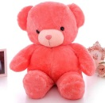[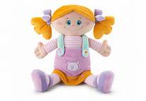](http://www.bing.com/images/search?q=teddy+with+doll&qs=n&form=QBIR&pq=teddy+with+doll&sc=0-10&sp=-1&sk=#view=detail&id=7A18C7F8FAB872C3F894C6393722C4A3955336A0&selectedIndex=80#view=detail&id=7A18C7F8FAB872C3F894C6393722C4A3955336A0&selectedIndex=80)give the ball and plate to dolly

give the cup and fork to teddy  
  
etc.

1. **Hiding objects**

Placing items in/on/under: Have three places to put things (e.g., bowl, bag, small chair). Collect some objects (e.g., spoon, toy cat, ball, brick). Ask your child to:

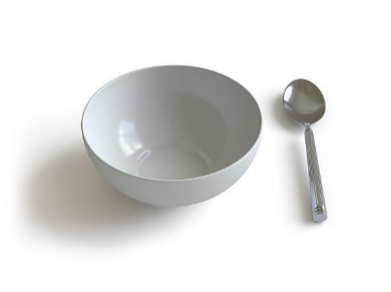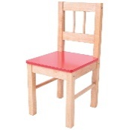put the dog under the chair

put the spoon beside the bowl  
 etc.

Remember that the child needs to wait to hear the full instruction before they start. Avoid giving extra clues by pointing or looking directly at the objects, as this will mean they do not have to understand any / all of the words.