Categorising

It is important to help children to understand the world around them through sorting and categorising activities that teach them to build associations between objects and support their vocabulary development.

Sorting game
Using objects or pictures from different groups, e.g., food, transport, clothes, animals. Explain what the categories are, e.g., these are things you can eat, they are all foods. These are things you travel in, they are types of transport etc.
Choose two different categories. At first choose two very different groups, e.g., food and animals. Muddle up the pictures or objects from both categories and ask your child to sort them into the groups. You could have a label or picture for each group to help them.
As the child sorts the pictures, name each picture and talk about the similar features, e.g., they all have four legs, they all live on a farm. To make this harder choose two similar groups, e.g., zoo animals and farm animals.

Odd one out
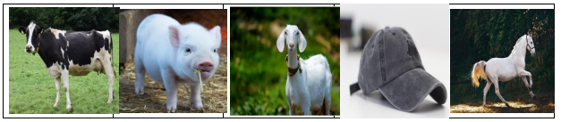
You will need: sets of pictures from the same category
For example:
Select 4-5 pictures in the same group/category and one that is not. Tell the child that you are going to find the odd one out and model to them how you did it, for example first label all the pictures then say “I think the hat is the odd one out because we wear it, it is clothing and the other ones are animals”.

Category dictionary
Use a scrapbook and title each page with different groups from a catalogue, e.g., home / toys. Cut up pages from the catalogue and sort which page they go on and talk about the similar features. Add new pictures as you come across them in magazines and catalogues. “I went to the shop…”

Category game
Choose a category, e.g., food or fruit. Take it in turns to name items that belong in the group e.g. “I went to the shop and bought an apple” “I went to the shop and bought an apple and a pear”.

