What will happen?
I am going to have a hearing check
My ____ will come with me to the clinic.
I will go in the lift or up the stairs to the room.
I will wait in the waiting room with the toys.
I will play listening games with the grown ups.
Then it will be time to go.**Audiology passport**

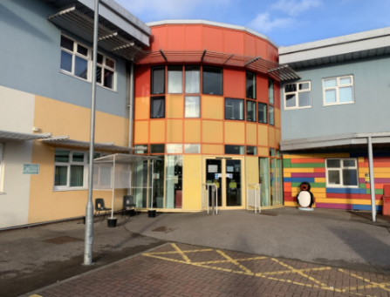

I will listen to sounds and may use the headphones

A grown-up will look in your ears with a light

This is where I will be going into.

This is our room there will be two grown-ups in here and they will talk to me.

After I have done all the games I can go home!

One of the grown-ups will explain and show me what to do.