Sound Play:
Helping your child’s early sound development

- You are your child’s best teacher – you are best placed to support their sound development!
- Playing with sounds together daily will help their speech sounds develop.
- Find 5 minutes twice a day to carry out sound play, or you can also use these ideas within your day-to-day activities and routines.
- Keep background noise to a minimum.
- Choose a time when your child is happy and calm, try to make it a time when it is just you and your child without distractions.
- If your child does not copy you making the sounds do not worry, a child needs to hear a sound many times before they will copy it. Just hearing the sound helps them learn to plan how to make a sound.
- Gain your child’s attention first – say their name or tap the toys you are using together.
- Be face to face. Hold the toys you are using near your face and mouth to encourage them to look at how the sound is made.
- Use a multisensory approach; make sure your child sees you making the sound, hears it and feels it (the airflow).
- Think about using front sounds first; these are sounds using lips and the tongue at the front of the mouth such as ‘p’,‘b’, ‘t’, ‘d’, ‘f’, ‘v’ – they are easier to see and this will help your child to copy them.
- Say the sounds quietly so they are not distorted. Make sure you say the sound not the letter name and that you do not add any other sound at the end (eg. “sss” not “ess” or “suh”)
- Reward any attempts to copy sounds with cuddles, smiles and praise! If your child does not copy, do not worry, just repeat the sound again.

Games to play with sounds:

Now you can play with your child using objects and toys, modelling sounds for them to listen to and eventually copy.

Linking sounds to objects will support your child in learning the sounds.

Here are some ideas of objects you can use but you can be creative and add your own ideas. Simply play with the toy with your child, make the sound, and occasionally use a word with the sound in (we have given suggestions here).

Make sure you have your child’s attention and are face-to-face. Make the sound play multi-sensory (see-hear-feel), say the sounds quietly, praise your child and repeat sounds.

‘p’  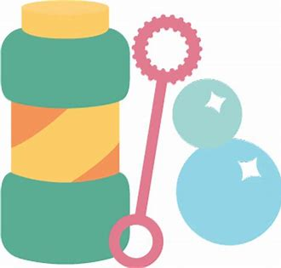 | - Bubbles – “p- p-p”  - Making “p” sound on a feather or piece of paper so you can see it move  - Do a fish impression in the mirror to make the lips come together  - Pretend to blow out a candle - to get lips together  ‘p’ short words  - "up" – when building brick towers or any toys that climbs "up, up, up".  - "pee-po" with scarves (see-through so can still see lips together modelled).  - “pop” – when popping bubbles
‘b’  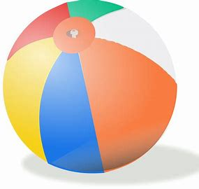 | - Bouncing a ball – “b-b-b”  - Pretending to be cold, e.g. whilst playing with a snowman/balls etc - "brrrr"  ‘b’ short words  - "boo" - making people/soft toys jump.  - "bye" - saying "bye bye" to the toys as you put them away.  - "bee" - tell a story/play sequence with the bee. (You can also try buzz buzz)  - "baa" - sheep sound
‘m’   | - Motorbike - "mmm"  - Feeding activity - "mmm" /"yummy"( or the opposite "errrrr"/"yuck")  - Baby babble with a dolly/ baby e.g. "mumumumum" etc  ‘m’ short words  - "more" - any games or activities to encourage this word  - "moo" - cow sound  - “meaow” – cat sound
‘n’   | - Aeroplane noise – “nnn “  ‘n’ short words  - “nee-nor” - police car, ambulance, fire engine  - "neigh" – horse sound  - "on/ in" e.g. when building a tower/ or putting a brick in a cardboard tube etc
‘t’  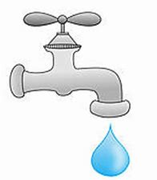 | - Dripping tap - “t-t-t“  - Pretending to type – “t-t-t”  - Ticking clock – “t-t-t”  ‘t’ short words  - “tea”- drinking tea as part of a tea party  - Tickle your “toe… toe, toe, toe”  - “eat” – feeding the puppet or toy  - “out” – in/out activity – pulling things out of a bag.  - ‘tut’ – make a ‘tutting’ sound whilst shaking your head ‘no’
‘d’  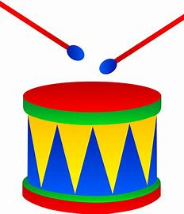 | - Playing drum - “d-d-d”  - Baby babble with a dolly/ baby e.g. "dadada" etc  ‘d’ short words  - “I do…. do, do, do”  - “oh dear” – when something goes wrong  - "daaar!" - reaction to something funny , surprising or an exclamation!
‘f’   | - Rocket/plane/firework taking off – “fff” (Talk about bunny rabbit teeth, top teeth over bottom lip)  - Blow up balloon and let it fly, saying “fff”.  - Model “fff” blowing feathers out of your hand  ‘f’ short words  - “off” – knocking toys ‘off’ table, taking people “off” the bus. You could even try “off-on, off-on…” etc  - “fee fi foe fum” – Jack and the Beanstalk phrase, use a giant’s voice!  - “woof” - dog sound
‘v’   | - Driving vehicles - “vvv”.  ‘v’ short words  - “va, va, voom” – revealing special toy/something exciting etc.
‘s’     | - snake sounds – “sss” (Smile whilst you are making the sound)  - pretend to be a balloon deflating going around and around - ‘sss’  ‘s’ short words  - “Yes” – yes/no  - “See/saw” – songs like see saw up and down, see saw margery daw, a sailor went to sea sea sea  - “I see…” looking through camera/telescope.  - “ice/icey”
‘z’   | - Buzzy bees – “zzz”  - Sleeping –“zzz”  ‘z’ short words  - Zoom zoom zoom song  - Zap! – with superhero action or sign

Here is a useful video by the Wiltshire Speech and Language Service demonstrating how you can explore speech sounds in play and everyday activities with your child. www.youtube.com/watch?v=yNQN4sWaUsI&t=9s

The Multi-Sensory Approach

We have talked about the importance of sound play being “Multi-Sensory”. You can see some great examples in this video by Oxford Spires Speech and Language Therapy Service. The videos were designed for children with cleft lip and palate but relevant for all parents who are supporting early speech sounds. You can find great examples of this approach from 3:15.

www.youtube.com/watch?v=UHPDrW_05HE&

This multisensory approach is helpful for all children. Keep thinking, can your child see, hear and feel the sound?

Here are some other fun ideas to encourage sound play and copying:

- Make funny faces in the mirror and encourage your child to copy you. Copy any faces your child makes. Move your tongue up and down and side to side. Make funny sounds – start with vowel sounds (ah/ee/oo) and babble (mamamam/babababa/lalalala), encourage your child to copy these too. Copy any sounds they make.
- Blowing: Blow a feather or toy windmill – take turns with your child
- Use kitchen rolls as a pretend trumpet to make noises through
- Body sounds: encourage your child to copy simple body sounds, e.g., clapping hands, tapping three fingers on one hand, stamping feet, slapping knees, clicking the tongue, kissing sounds, popping the cheek, making a fish sound with lips or blowing raspberries!

