
This social media toolkit can be used across Instagram, Twitter or Facebook to help young people get the right help by texting ChatHealth in Beds and Luton.

Graphic | Social media text
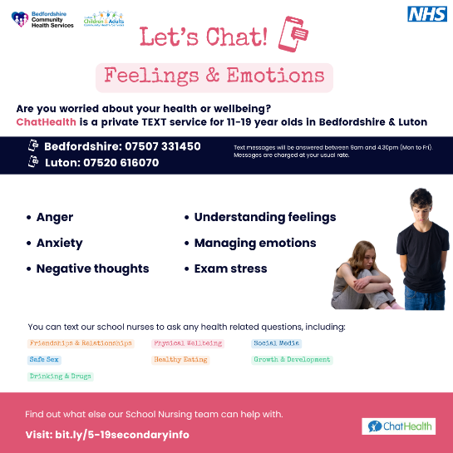 | Do you need advice on feelings & emotions?  Text our school nurses through ChatHealth!  If you're 11-19 years old and live in Bedfordshire or Luton, send your questions to 07507 331450 (Bedfordshire) or 07520 616070 (Luton).  It's confidential, anonymous, and easy to use! 📱💬 #  HealthSupport #YouthWellbeing #Bedfordshire #Luton
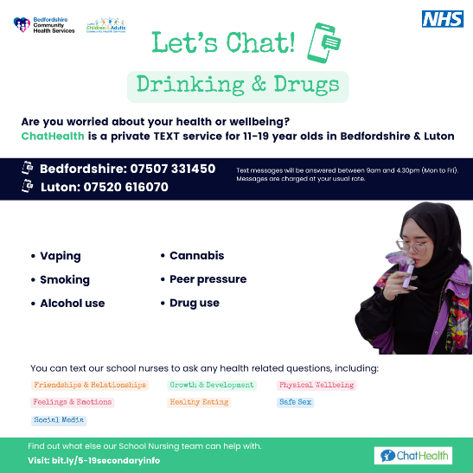 | Are you struggling with drinking and drugs and need advice? ChatHealth is here to help!  Text our school nurses at 07507 331450 (Bedfordshire) or 07520 616070 (Luton) with questions about mental health, drugs, relationships, or anything else.  For 11-19-year-olds, it's confidential and anonymous. 🗣️📲  #TeenHelp #ChatHealthBeds #ChatHealthLuton
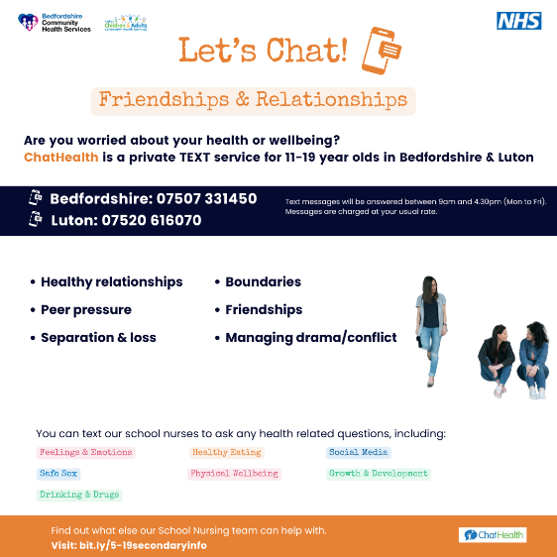 | Got questions about your friendships and relationships?  ChatHealth is a text service for 11-19 year olds in Bedfordshire and Luton.  Text 07507 331450 (Bedfordshire) or 07520 616070 (Luton) to speak with a school nurse confidentially and anonymously.  Ask about mental health, relationships, and more! 💡📞  #SupportForTeens #ChatHealthBeds #ChatHealthLuton
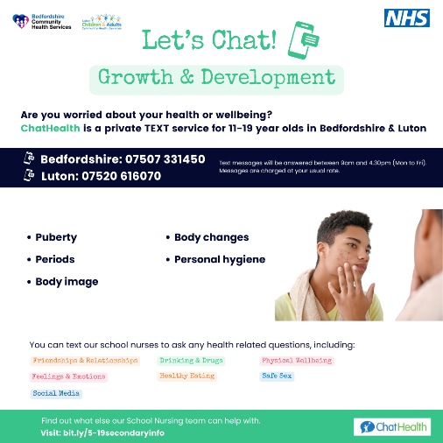 | 11-19 years old and have questions on growth and development?  ChatHealth lets you text our school nurses anonymously about growth and development, mental health, healthy eating, and more.  Send your questions to 07507 331450 (Bedfordshire) or 07520 616070 (Luton). We're here to help! 💬🩺  #YouthSupport #MentalHealthMatters
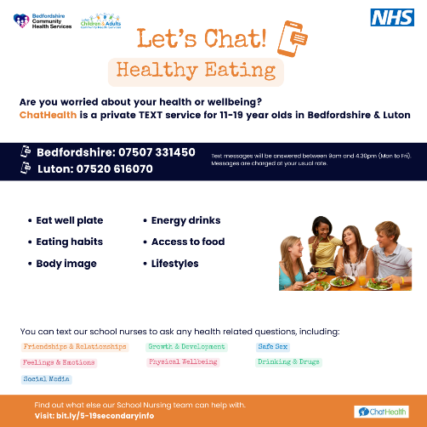 | Sometimes you just need to talk... and we're listening.  Text ChatHealth at 07507 331450 (Bedfordshire) or 07520 616070 (Luton) if you're 11-19 and want to ask about health-related topics like healthy eating, mental health, relationships, or drugs. It's easy, anonymous, and confidential. 💙📱  #TalkItOut #ConfidentialHelp
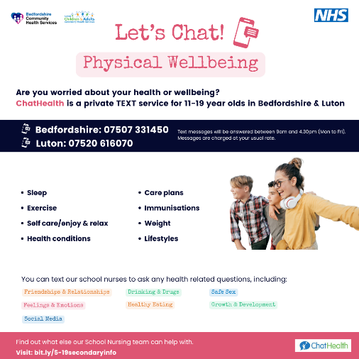 | ChatHealth is here for you!  If you're between 11-19 years old in Bedfordshire or Luton, text our school nurses for confidential and anonymous advice.  Get answers on physical wellbeing, mental health, relationships, and more at 07507 331450 (Bedfordshire) or 07520 616070 (Luton). 💬🧠  #HealthQuestions #YouthAdvice
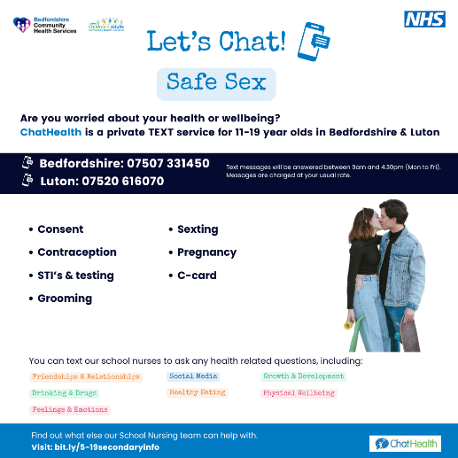 | Your health matters, and ChatHealth makes it easy to ask for help!  11-19 year olds in Bedfordshire and Luton can text school nurses for confidential advice on anything from safe sex to relationships.  Reach out at 07507 331450 (Bedfordshire) or 07520 616070 (Luton) today! 📱  #HereToHelp #TeenMentalWellbeing
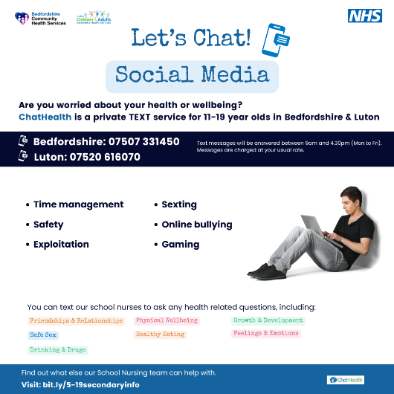 | Need health advice but want to stay anonymous?  ChatHealth lets 11-19 year olds in Bedfordshire and Luton text school nurses confidentially about social media, mental health, drugs, relationships, and more.  Text 07507 331450 (Bedfordshire) or 07520 616070 (Luton) today! 💬🩺  #ConfidentialCare #ChatHealthSupport

